KHULNA UNIVERSITY OF ENGINEERING & TECHNOLOGY

Department of Electronics & Communication Engineering

Report on

**220V AC Voltage Stabilizer**

Course No : ECE-2200

**Group: B 14**

**Submitted to: Submitted by:**

***Mr. Md. Mehedi Hasan* Tamanna Akter(1409055)**

***Mr. Shuvashish Saha* Mahmudur Rahman(1409056)**

**Biplob Kumar Biswas(1409057)**

**Ferdos Hasan Nion(1409019)**

Date of Submission: **20/12/2016**

**Contents**

* **Objectives**
* **Introduction**
* **Background & market potential**
* **Overview**
* **Theory**
* **Block diagram**
* **Operation**
* **Apparatus required**
* **Circuit diagram**
* **Circuit description**
* **Practical view**
* **Data analysis**
* **Circuit stability**
* **Application**
* **Limitations**
* **Improvement**
* **Discussion**
* **Conclusion**
* **References**

**Objectives:**

-To maintain a constant voltage level, 220V ac.

-To regulate electronic components one or more ac or dc voltages.

-To protect household appliances from voltage surges that destroys it.

-To maintain an output that is very close to normal main voltage as possible under conditions of fluctuations.

**Introduction:**

A voltage stabilizer is a device which is used to sense inappropriate voltage levels and correct them to produce a reasonably stable output where the load is connected. Here we will study the design of a simple automatic AC voltage stabilizer which can be used for the above purpose. In this circuit, active and passive devices, such as diodes, transformer, resistor, capacitor, relay, IC etc. have been used. One step down transformer and power transformer have also been used in this work. In case the line voltage crosses a predetermined threshold, the comparator detects it and its output immediately goes high, switching ON the transistor and the relay for the desired actions. The relay contacts are appropriately integrated to the transformer taps for executing the above actions as per the commands given by the op amp output. The designed circuit operates successfully and the results obtained are satisfactory. When installed, the relay trips whenever the input voltage crosses 230 volts, bringing the output to 218 volts and keeps it until the voltage reaches higher levels. When the voltage drops back to 225, the relay gets de-energized pulling the voltage to 238 volts and maintains the difference as the voltage further goes down. The above action keeps the output to the appliance well between 200 to 250 volts with fluctuations ranging from 180 to 265 volts.

The Voltage stabilizer provides an output voltage with a specified limit for supplying to load irrespective of wide fluctuation in the input voltage, independent of load power factor and without introducing harmonic distortion. The voltage stabilizer adjusts automatically the voltage variation whether high or low to the proper voltage level necessary for the safe operation of equipment.

**Background & market potential:**

Consumer electronic products are the backbone of the electronic industry in the country. Consumer electronics contributes about one third of total electronics production in the country. Since the item is of great utility of the consumer electronics its demand is growing at a rapid pace in keeping with the increasing production of consumer electronics item. Excessive voltage fluctuation are hazard to costly electronic and electrical equipment like T.V. sets, VCRs, refrigerators and other scientific and medical equipment etc. Voltage stabilizers are used along with these equipment to protect them from damage due to wide line voltage fluctuations The project report titled 'automatic voltage stabilizer' includes Present Market Position and Expected Future Demand, Market Size, Statistics, Trends, SWOT Analysis and Forecasts. Report provides a comprehensive analysis from industry covering voltage stabilizer and it is detailed reporting and evaluates the significance of stabilizer.

**Overview:**

To implement the stabilizer, components are assembled on a printed circuit boards as per the circuit design. The assembled PCB, Relay, Transformer, switch indicating lamps and power cables are further assembled to form a compact unit. The whole assembled unit is enclosed in metal case with an appealing front panel. Finally the stabilizer is tested for the performance as per the design. A voltage stabilizer is a device which is used to sense inappropriate voltage levels and correct them to produce a reasonably stable output at the output where the load is connected. The power line fluctuations and cut-offs cause damages to electrical appliances connected to the line. It is more serious in the case of domestic appliances like Fridge and Television. If a fridge is operated on low voltage, excessive current flows through the motor, which heats up, and get damaged. The high/low voltage protection circuit with time delay presented here is a low cost and reliable circuit for protecting such equipements from damages. Whenever the power line is switched on it gets connected to the appliance only after a delay of a fixed time. If the power down time (time for which the voltage is beyond limits) is less than the delay time, the power resumes after the delay: If it is equal or more, then the power resumes directly.

This circuit has been designed, built and evaluated by us.

**Theory:**

A voltage stabilizer is a device which is used to sense inappropriate voltage levels and correct them to produce a reasonably stable output at the output where the load is connected. Which is fabricated using transistor and other discrete components. It can be used to protect loads such as TV, Refrigerator and VCR from undesirable over and under line voltages, as well as surges caused due to sudden failure/resumption of mains power supply. This circuit can be directly as standalone circuit between the main supply and the load, or it may be inserted between an existing automatic/manual stabilizer and the load. In case the mains voltage crosses a predetermined threshold, the ICs non inverting detects it and its output immediately goes high, switching ON the transistor and the relay for the desired actions.

The relay, which is a DPDT type of relay, has its contacts wired up to a transformer, which is an ordinary transformer modified to perform the function of a stabilizer transformer.

So if the input AC voltage tends to increase a set threshold value, the transformer deducts some voltage and tries to stop the voltage from reaching dangerous levels and vice versa during low voltage situations.

**Block diagram:**

By following this block diagram we first attempt to our voltage stabilizer implementation.

Fig1.1: Block diagram of Voltage Stabilizer

**Operation:**

220V ac input supply from supply line and flow the ac voltage of rectifier. Rectifier chance the voltage ac to dc and capacitor chance the filtering dc. Operational amplifier or comparator compare the ac supply voltage. Relay is an Electrical switching device. Its Normally-open (NO) contacts connect the circuit when the relay is activated the circuit is disconnected when the relay is inactive. Normally-closed (NC) contacts disconnect the circuit when the relay is activated; the circuit is connected when the relay is inactive. Change-over (CO), or double-throw (DT), contacts control two circuits: one normally-open contact and one normally-closed contact with a common terminal. Output voltmeter show the stable voltage.

**Apparatus required:**

Resistors = 1 K(4 pieces).

Variable Resistor = 10 k(4)

Capacitor C1 = 1000 micro fraday

Diode D1 & D2 = 4

Zener Diode Z1 & Z2 =6 Volt

Transformer =4 phase ,

Op-Amp = ic lm-324

Transistor = 2N2222,

Relay =12 v

LED =4 pieces

IC = IC 7809.

**Circuit diagram:**

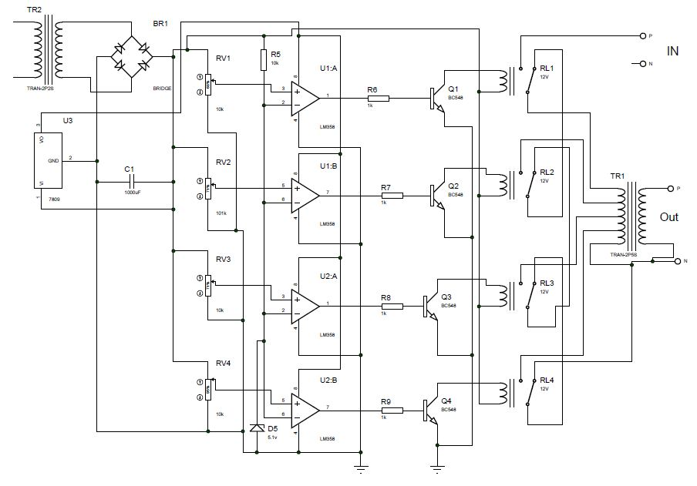

Figure 1.2: Circuit diagram of ac voltage stabilizer

**Circuit description:**

220V ac input supply from supply line and flow the ac voltage of rectifier. Rectifier chance the voltage ac to dc and capacitor chance the filtering dc. Operational amplifier or comparator compare the ac supply voltage.

Circuit operation can be divided into three major parts.

1. Rectification part

2. Comparator part

3. Transformer part

**Rectification part:**

First connection will be ac input voltage from bridge rectifier for rectification. This rectification is needed to compare whether it is in normal condition or voltage up or voltage down condition.

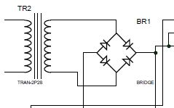

fig1.3:Bridge rectifier circuit.

**Comparator part:**

After the connection of bridge rectifier , input voltage should be compared to normal voltage or different stages of voltage. Here in our circuit, we can compare input voltage in four voltage level and they are 180V, 200V, 220V, 240V ac . By tuning variable resistor voltage divider method is applied to make comparator op-amp compare and produce output according to input voltage level. Here resistor R1, R2, R3, R4 is tuned such a manner that for 180V it turns comparator 1 on and keeps other comparator off, similarly for 240V input it turns comparator 4 on. When the any of the comparators turns on it also turns corresponding relay on and supplies voltage to selected primary windings of transformer.

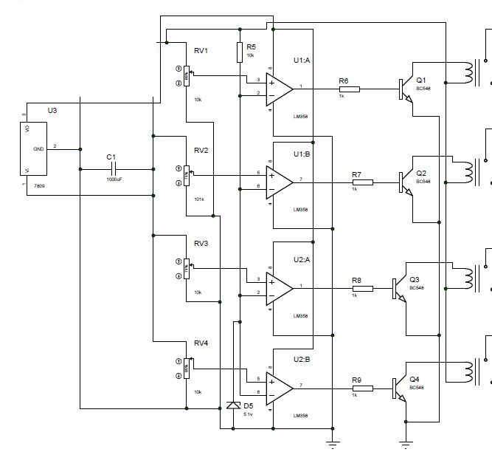

fig1.4: Circuit for comparator part

In this project we have used IC LM324 in place of four individual Opamp.

IC LM324 contains four Opamps in one ic.

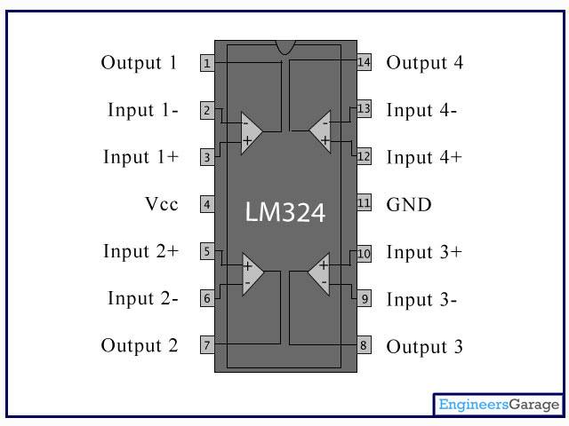

fig1.5: IC LM324

**Transformer part:**

Basic principles a transformer is an electrical device that transfers energy between two or more circuits through electromagnetic induction.

A varying current in the transformer's primary winding creates a varying magnetic flux in the core and a varying magnetic field impinging on the secondary winding. This varying magnetic field at the secondary induces a varying electromotive force (emf) or voltage in the secondary winding. Making use of Faraday's Law in conjunction with high magnetic permeability core properties, transformers can thus be designed to efficiently change AC voltages from one voltage level to another within power networks. Transformers have become essential for the AC transmission, distribution, and utilization of electrical energy.

For any transformer

$\frac{tunrs on secondary coil}{turns on primary coil} =\frac{voltage in secondary coil}{voltage in primary coil}$

So output voltage depends on transformer turns as well as input voltage. Here changing turns for changing input voltage, constant output can be obtained. After comparator turning on relays, the relays turn on different portion of windings of transformer. The transformer is the most important part of the circuit that is designed particularly for 220V stabilization. The transformers turn ratio is selected in such a way that whenever it is 180V output voltage will be 220 V. again when input is 240 V the turn ration is selected in such a manner that it produces 220V ac output.

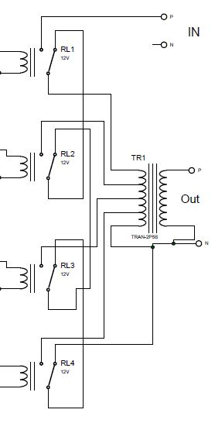

fig:1.6: Power transformer circuit

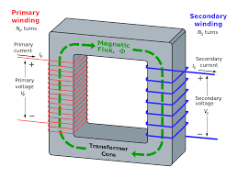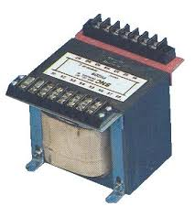fig1.7: Transformer used for this circuit step down transformer and power transformer

There are some other basic components which made important role for the implementation of the voltage stabilizer. Their operation and nature are described below shortly.

**Capacitor:**

A capacitor (originally known as a condenser) is a passive two-terminal electrical component used to store energy electro statically in an electric field. The forms of practical capacitors vary widely, but all contain at least two electrical conductors (plates) separated by a dielectric (i.e. insulator). The conductors can be thin films, foils or sintered beads of metal or conductive electrolyte, etc. The "non-conducting" dielectric acts to increase the capacitor's charge capacity. A dielectric can be glass, ceramic, plastic film, air, vacuum, paper, mica, oxide layer etc.

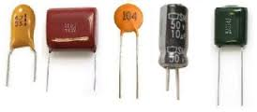

fig1.8:Different types of capacitors.

Capacitors are widely used as parts of electrical circuits in many common electrical devices. Unlike a resistor, an ideal capacitor does not dissipate energy .These makes huge importance in this circuit implementation.

**Resistor:**



fig1.9: Resistors

A resistor is a passive two-terminal electrical component that implements electrical resistance as a circuit element. Resistors act to reduce current flow, and, at the same time, act to lower voltage levels within circuits. In electronic circuits resistors are used to limit current flow, to adjust signal levels, bias active elements, terminate transmission lines among other uses. High- power resistors that can dissipate many watts of electrical power as heat may be used as part of motor controls, in power distribution systems, or as test loads for generators. Resistors may have fixed resistances that only change a little with temperature, time or operating voltage. Variable resistors can be used to adjust circuit elements (such as a volume control or a lamp dimmer), or as sensing devices for heat, light, humidity, force, or chemical activity.

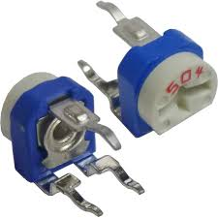

fig1.10:Variable resistors

We have used both normal resistors and variable resistors.

**Diode:**

The most common function of a diode is to allow an electric current to pass in one direction (called the diode's forward direction), while blocking current in the opposite direction (the reverse direction).

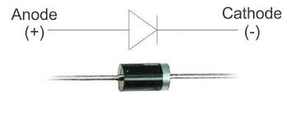fig1.11: Diode

**Relay:**

A relay is an electrically operated switch. Many relays use an electromagnet to mechanically operate a switch, but other operating principles are also used, such as solid-state relays. Relays are used where it is necessary to control a circuit by a low-power signal (with complete electrical isolation between control and controlled circuits), or where several circuits must be controlled by one signal.

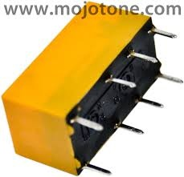

fig1.12: Relay

**Transistor:**

BC547 is an NPN bi-polar junction transistor. A transistor, stands for transfer of resistance, is commonly used to amplify current. A small current at its base controls a larger current at collector & emitter terminals. BC547 is mainly used for amplification and switching purposes. It has a maximum current gain of 800. Its equivalent transistors are BC548 and BC549.

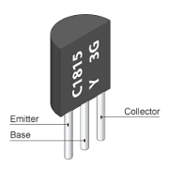

fig1.13: Transistor

**PCB layout :**

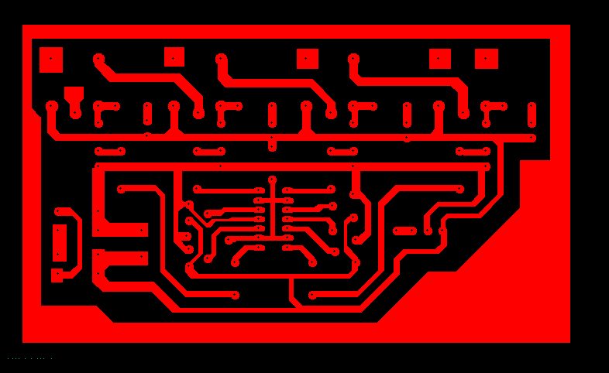

Fig: PCB layout.

**Practical view:**

Our first try to PCB board implementation is given below:

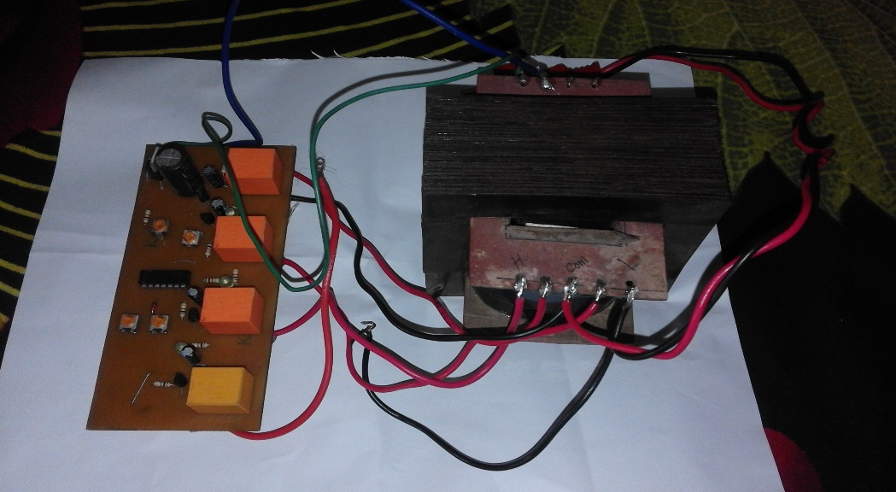

fig1.14: PCB board implementation.

**Data analysis:**

|  |  |  |
| --- | --- | --- |
| Input Voltage Range (V) | Switching voltage | Output |
| 180-200 | 179 v | 228 v |
| 200-220 | 206 v | 234 v |
| 220-240 | 220 v | 221.6 v |
| 240-260 | 246 v | 213.3 v |

**Circuit stability:**

From the data analysis table our output voltage is varied from 213.3 v-234 v. The variation of the voltage almost 20 v. It is not highly perfect stabilizer because we used 4 leg winding transformer**.**

**Applications:**

Different voltage stabilizer are used for different appliance according to the specification and usage of each device .There are TV stabilizer , refrigerator stabilizer, stabilizers for washing machine ,music systems, specialized voltage stabilizers for digital TV’s, LED TV’s and LCD TV’s.

.

**Limitations:**

When installed, the relay trips whenever the input voltage crosses 230 volts, bringing the output to 218 volts and keeps this distance continuously as the voltage reaches higher levels.

When the voltage drops back to 225, the relay gets de-energized pulling the voltage to 238 volts and maintains the difference as the voltage further goes down.

The above action keeps the output to the appliance well between 213.3 to 234 volts with fluctuations ranging from 180 to 265 volts.

**Improvement:**

In our stabilizer, we used 4 leg winding transformer. So our voltage range varied 20 v. As well as our output also varied around 20v. If we use 8 legs or more winding transformer then our output will be more stabilized. In this way, we improve our stabilizer accurately.

**Discussion:**

The main utilities of our project was:

* Over-voltage protection

* Under-voltage protection

* Protection against transients

* High reliability

* High performance

* Low cost

*protection to load from frequent turning ON & OFF by providing time delay. Under-voltage relay, in case the mains voltage starts fluctuating in the vicinity of under or over voltage preset points.

* It can be used to protect loads such as refrigerator, T.V and VCR from undesirable over and under line voltages.

It is an inexpensive automatic voltage stabilizer circuit, which is fabricated using transistors and other discrete components. It can be used to protect loads such as refrigerator, TV and VCR from undesirable over and under line voltages, as well as surges caused due to sudden failure/ resumption of mains power supply. A voltage stabilizer is a device which is used to sense inappropriate voltage levels and correct them to produce a reasonably stable output at the output where the load is connected. Here we will study the design of a simple automatic mains AC voltage stabilizer which can be applied for the above purpose .The IC is wired as a comparator, we all know how well this mode suits the ICs and other op amp sIt becomes the control section of the whole design. It's two inputs are suitable rigged for the said operations. Now you may connect both the transformer to its appropriate positions with the circuit. Our simple voltage stabilizer circuit is ready.

**Conclusion:**

First start with great thank to almighty, we were taken this opportunity to emplement this project “220V AC Voltage Stabilizer ”.We are very thankful to our honourable teachers for their proper guidance. We can’t say thank you enough for their tremendous support and help. We feel motivated and encouraged every time during this project. Our group work was amaizing and we were very helpful to each other.Our project has become successful and well implemented at last.We think this project will help us in future for further new preject work.

**References:**

1. http://www.diy-electronic-projects.com/p183-High-and-low-voltage-cut-off-with-time-delay

2. http://electronicseverywhere.blogspot.com/2010/11/overunder-voltage-cut-off-with-on- time.html

3. www.wikipedia.org

4. http://www.todaysengineer.org/2003/May/history.asp

5.http://www.google.com/patents?id=uBFMAAAAEBAJ&printsec=abstract#v=onepage&q&f =false